33nd ISME World Conference
& Commission Seminars
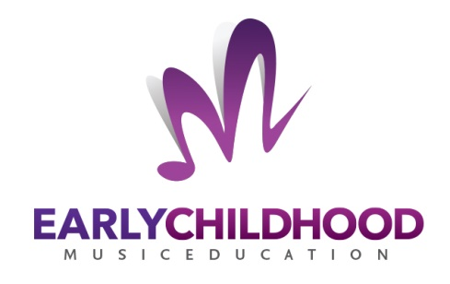

The 18th Pre-Conference International Seminar

YOUNG CHILDREN’S MUSICAL JOURNEYS
Sunday, July 8 through Thursday, July 12, 2018

Hosted by Beit Almusica
Shefa’Amr, Israel
https://www.isme-commissions.org/ecme.html

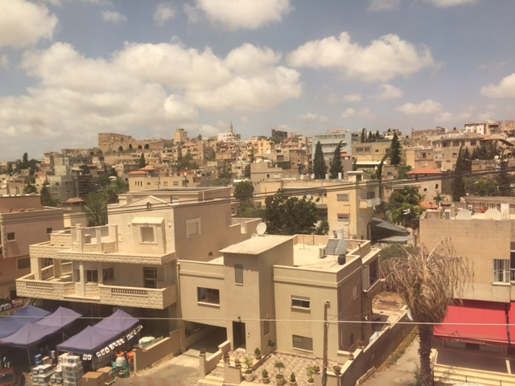

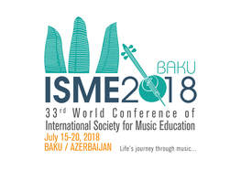

Life’s Journey Through Music

July 2018

Dear ECME Participants,

It is my distinct honor to welcome you to the 18th International Early Childhood Music Education Seminar in Shefa’Amr. After much planning, organizing, skyping, e-mailing, and telephoning, we have finally arrived at this most special gathering at Shefa’Amr in Israel. The Commissioners have worked diligently to make this international exchange memorable and meaningful. I should like to take this opportunity to thank each of them publicly: Suzanne Burton, Claudia Gluschankof, Chee-Hoo Lum and Jessica Pérez-Moreno.
On behalf of the Commissioners, I offer heartfelt gratitude for the amazing hospitality of Beit Almusica and its staff. We could not have done it without you! I should like to extend my deepest thanks to Amer Nakhleh, General Director, Ruba Simaan, Project Coordinator, and Iman Jabbour, Assistant, especially. You are an extraordinary team!

Finally, at this important intersection of cultures, we have the great privilege of sharing ideas, posing questions, offering insights, and forming bonds of friendship around early childhood music education. The beautiful contrapuntal tapestry that we will weave this week will result in a lively exchange with colleagues from around the world: Australia to Portugal, Finland to Kenya, Tanzania to Singapore, Iceland to Israel, China to Cyprus, Spain to The Netherlands, and eight United States. Together we hold the potential to cultivate understanding, appreciate multi-cultural viewpoints, and integrate that which is distinct to our multiple and varied cultures. Weaving the single threads of our musical journeys into a collective, collaborative commitment, we share the promise of raising a generation of children who learn to respect and honor difference, distinction, and diversity by finding and making meaning through musical expression. Music may very well be the medium through which we create reconciliation and unity for our world.

Thank you for being here and for sharing your musical journey with us!

Warmest personal regards,

Patricia St. John, CSJ, Ed. D
Chairperson
Early Childhood Music Education Commission

Adjunct Associate Professor of Music and Music Education
Teachers College, Columbia University
New York, NY
USA
ECME 2018
 | SUNDAY  July 8 | MONDAY  July 9 | TUESDAY  July 10 | WEDNESDAY  July 11 | THURSDAY  July 12
 | Daily Host: Patricia | Musical Journeys across National and Ethnic Contexts  Daily Host: Chee-hoo | Educators’ Musical Journeys in Professional Contexts  Daily Host: Jessica | Musical Journeys through Community Contexts  Daily Host: Suzanne | Children’s Musical Journeys  Daily Host: Claudia
9:00 |  | Welcome and  Introduction of Guests | Song-sharing:  AUDITORIUM | Song-sharing:  AUDITORIUM | Song-sharing:  AUDITORIUM
9:15 |  |  | Paper: Deepening educators’ understanding of young children’s musical journeys  Laura Huhtinen-Hildén  Amanda Niland  Discussant: Michel Hogenes | Announcements and Excursion Details | Announcements
9.30 |  | Song-sharing:  AUDITORIUM |  | Paper: Infants act-by-act: Observing infants peer play  Nita Baxani  Discussant: Amanda Niland | Paper: The practice of agency in the life-span of a child  Lauren Kooistra  Discussant: Laura Huhtinen-Hildén
9.45 |  |  | Workshop/Performance—Apartment For Rent: Who will take it?  Eva Brand and Ludmilla Legorov  Discussant: Nita Baxani
10.00 |  | Around the Table  “Challenges and dilemmas in early childhood education and  early childhood music education in Israel”  Prof. Veronika Cohen  Prof. Margarlit Ziv |  | Workshop: Multicultural early cildhood music programs for Jews and Arabs  Michal Hefer  Discussant: Gabriele Schellberg | Paper: Audiation from the womb—Musical transfer from utero to infancy  Krystal McCoy  Discussant: Sheila Woodward
10.30 |  |  |  |  | Coffee Break
11.00 |  |  |  | Coffee Break/Poster Exploration | Open Discussion
11:15 |  |  | Coffee Break
11.30 |  | Coffee Break | Paper: Journeys toward empowerment—  Educators sharing their musical cultural identities with children  Jill Holland and Amanda Niland  Discussant: Chee-hoo Lum | Open Discussion | Paper: How we learn to sing—Studies on singing in 2- and 3-year-olds  Helga R.  Gudmundsdottir  Discussant: Krystal McCoy
12.00 |  | Paper: Audio graphic journeys of kindergarten children across two nations: Israel and Germany  Rivka Elkoshi and Gabriele Schellberg  Discussant: Suzanne Burton | LUNCH | EXCURSIONS | LUNCH
12:30 |  | Paper: Early childhood policy and practice in Tanzania: Music in the new kindergarten curriculum  Eugenia Costa-Giomi and Patrick Msuya  Discussant: Elizabeth Andang’o
13:00
Schedule at a Glance
Mornings:

Afternoons:

 | SUNDAY  July 8 | MONDAY  July 9 | TUESDAY  July 10 | WEDNESDAY  July 11 | THURSDAY  July 12
14.00 |  |  | Workshop: “Colos de Música” (trad. Music Laps)—A tool for building inner gardens  Ana Isabel Pereira, Helena Rodrigues, Paulo Ferreira Rodrigues, Paulo Maria Rodrigues  Discussant: Jill Holland |  | Paper: Exploring young children’s self-initiated singing in the playground  Elizabeth Andang’o  Discussant: Sara Zur
14:30 |  |  |  |  | Workshop: Childhood pathways to music learning—Lessons from Moshe Feldenkrais  Lori Custodero  and Raz Ori  Discussant: Michal Hefer
15.00 |  | Paper: The image of the child in preschool curriculum—Australia vs. China  XiangYi Tao  Discussant: Pamela Stover | Paper: Music in preschool—The Kodály-inspired work of Katalin Forrai and Jean Sinor  Pamela Stover  Discussant: Helga Gudmundsdottir
15:30 |  | Poster Presentations | Coffee Break/Poster Exploration |  | Open Discussion
16:00 | Check In | Coffee Break | Paper: Relationships among musical home environment, parental involvement, demographic characteristics and early childhood music participation  Adrienne Rodriguez  Discussant: Lauren Kooistra |  | Final Remarks
16:30 |  | Paper: Early musical journeys determining musical values, identity and learning  Sheila Woodward  Discussant: Lori Custodero | Open Discussion
17.00 | Opening Reception | Open Discussion |  |  | Free time before dinner
18:30
18:00 | Workshop: “Huhuu, who are you?” A musical and creative journey with a story  Soili Mirjami Perkiö  Discussant: Jessica Pérez | Concert—  Beit Almusica Choir  Lilia Bazogli, Conductor  Beit Almusica Arabic Music Ensemble,  Loay Khlef, Conductor | Concert—  Charaz Mghana—Songs for children  Rhozan Khoury, vocalist and Beit Almusica instrumentalists
18:30 |  | Depart for Nazareth (Hotel) | Depart for Nazareth (Hotel) |  | Conference Dinner  Concert—  Beit Almusica Rock-Jazz Quartet  On to Finland!
19:00 | Concert—Contemporary Palestinian Piano Music  Pianist: Fady Deeb
19:30 | Depart for Nazareth (Hotel)

PROGRAM
Sunday

16:00 Check-in facilitated by the Staff of Beit Almusica

17:00 Opening Reception

18:00 Workshop: “Huhuu, who are you?” A musical and creative
journey with a story
Soili Mirjami Perkiöi, Sibelius Academy, Finland
- Discussant: Jessica Pérez-Moreno

19:00 Concert— Contemporary Palestinian Piano Music
- Fady Deeb, pianist

Monday: Musical Journeys across National and Ethnic Contexts
9:00 Welcome Patricia St John, ECME Commission Chair
9:15 Introduction of Host and Honored Guests
9:30 Song Sharing
10:00 Around the Table
“Challenges and dilemmas in early childhood education and
early childhood music education in Israel”

- Introduction and brief history of early childhood music education in Israel—Claudia Gluschankof

- Moderator—Patricia St John

- Panelists:

Professor Veronika Cohen
Professor Emeritus at the Jerusalem Academy of Music where she had served as chairman of the Music Education Department for many years as well as several terms as dean of the faculty of Composition, Conducting , Theory and Music Education. Dr. Cohen is a former MISTEC Commissioner as well as a Member of the national curriculum in music, and member of the early childhood national curriculum in the arts, the Ministry of Education, Israel. She continues her teaching and research activities with a focus on creativity and the use of Musical Mirrors - a method for in depth listening that she has developed.
Professor Margalit Ziv
Professor Ziv is an academic consultant of- and senior lecturer in the early childhood Masters program at Kaye Academic College of Education and senior lecturer at the Kibbutzim Academic College of Education, Technology and Arts. Her research and practice focus on theory of mind, promoting children’s social understanding via shared book reading, and education for a peaceful and just society.
11:30 Coffee
12:00 Paper: Audio graphic journeys of kindergarten children across two nations: Israel and Germany
Rivka Elkoshi, Levinsky College of Education, Israel
Gabriele Schelberg, University of Passau, Germany
- Discussant: Suzanne Burton

12:30 Paper: Early childhood policy and practice in Tanzania: Music in the new kindergarten curriculum
Eugenia Costa-Giomi, The Ohio State University, USA
Patrick Msuya, Tumaini University Makumira, Tanzania
- Discussant: Elizabeth Andang’o

13:00 Lunch

15:00 Paper: The image of the child in preschool curriculum—Australia vs. China
XiangYi Tao, University of Sydney, Australia
- Discussant: Pamela Stover

15:30 Poster Presentations
Dreams to Drums: Constructing a Music Playground with Young Children
Sara Zur, Buckingham, Brown, & Nichols School

The impact of music education in the early years: Eight life stories
Jessica Perez Moreno¹ & Carmen Carrillo²
¹ Universitat Autonoma de Barcelona
² International University of Catalonia

The Relationship between the Recognition of Songs and Two Song-teaching Strategies among Kindergarten: A Qualitative Analysis on Interview Data
Ana Isabel Pereira¹ & Helena Rodrigues²

¹ Laboratory of Music and Communication in Infancy (LAMCI) - Centre for the Study of the Sociology and Aesthetics of Music (CESEM), Faculty of Human and Social Sciences (FCSH) - Universidade NOVA de Lisboa.
² Department of Musical Sciences, Laboratory of Music and Communication in Infancy (LAMCI) - Centre for the Study of the Sociology and Aesthetics of Music (CESEM), Faculty of Human and Social Sciences (FCSH) - Universidade NOVA de Lisboa.

Performing arts for infancy: A video-based research
Mariana Vences¹, Miguel Barbosa², Ana Isabel Pereira¹,Paulo Rodrigues³,
Helena Rodrigues⁴

¹CESEM - NOVA FCSH. Lisboa, Portugal
²CESEM - NOVA FCSH. Lisboa, Portugal; Universidade de Lisboa, Faculdade de Medicina, Lisboa, Portugal
³DeCA - Universidade de Aveiro, Aveiro, Portugal; INET-MD, Aveiro, Portugal; CMT, Lisboa, Portugal
⁴CESEM - NOVA FCSH. Lisboa, Portugal; CMT, Lisboa, Portugal
Cooee! - Breaking educators out of the “But I can’t sing!’ cycle. Enabling children’s musical journeys through enabling their educators
Anna Mlynek-Kalman, Music Works Magic

16:00 Coffee Break

16:30 Paper: Early musical journeys determining musical values, identity and learning
Sheila Woodward, Eastern Washington University, USA
- Discussant: Lori Custodero

17:00 Open Discussion facilitated by Chee-Hoo Lum
18:00 Concert— Beit Almusica Choir, Lilia Bazogli, Conductor;
Beit Almusica Arabic Music Ensemble, Loay Khlef, Conductor

18:30 Depart Shefa’Amr for Nazareth (Hotel)

Tuesday: Educators’ Musical Journeys in Professional Contexts
9:00 Song Sharing
9:15 Paper: Deepening educators’ understanding of young children’s musical journeys
Laura Huhtinen-Hildén, Helsinki Metropolia University of Applied Sciences, Finland
Amanda Niland, University of Sydney, Australia
- Discussant: Michel Hogenes

9:45 Workshop/Performance—Apartment for Rent: Who will take it?
Eva Brand, The Bar Ilan Univeristy, Israel
Ludmilla Legorov, The Bar Ilan University, Israel
- Discussant: Nita Baxani
11:15 Coffee Break

11:30 Paper: Journeys toward empowerment- Educators sharing their musical cultural identities with children
Jill Holland, Macquarie University, Australia
Amanda Niland, University of Sidney, Australia
- Discussant: Chee-Hoo Lum
12:00 Lunch
14:00 Workshop: “Colos de Música” (trad. Music Laps)—A tool for building inner gardens
Ana Isabel Pereira, Helena Rodrigues,
Paulo Ferreira Rodrigues, Paulo Maria Rodrigues,
Laboratory of Music and Communication in Childhood-Musical Aesthetics and Sociological Studies Research Centre, Faculty of Social Sciences and Humanities of the Universidade Nova de Lisboa, Portugal
- Discussant: Jill Holland

15:00 Paper: Music in preschool—The Kodály-inspired work of Katalin Forrai and Jean Sinor
Pamela Stover, University of Toledo, USA
- Discussant: Helga Gudmundsdottir

15:30 Coffee Break/Poster Exploration
16:00 Paper: Relationships among musical home environment, parental involvement, demographic characteristics and early childhood music participation
Adrienne Rodriguez, Michigan State, USA
- Discussant: Lauren Kooistra

16:30 Open Discussion facilitated by Jessica Pérez-Moreno
18:00 Concert— Rhozan Khoury, vocalist accompanied by Beit Almusica instrumentalists

18:30 Depart Shefa’Amr for Nazareth (Hotel)

Wednesday: Musical Journeys through Community Contexts

9:00 Song Sharing

9:15 Announcements and Excursion Details

9:30 Paper: Infants act-by-act: Observing infants peer play
Nita Baxani, Teachers College/Columbia University, USA
- Discussant: Amanda Niland

10:00 Workshop: Multicultural early childhood music program for Jews and Arabs
Michal Hefer, Jerusalem Academy of Music and Dance, Israel
- Discussant: Gabriele Schellberg

11:00 Coffee Break/Poster Exploration
11:30 Open Discussion facilitated by Suzanne Burton
12:00 Depart for excursions

Thursday: Children’s Musical Journeys

9:00 Song Sharing
9:15 Announcements
9:30 Paper: The practice of agency in the life-span of a child
Lauren Kooistra, Penn State University, USA
- Discussant: Laura Huhtinen-Hildén

10:00 Paper: Audiation from the womb—Musical transfer from utero to infancy
Krystal McCoy, Southern Utah University, USA
- Discussant: Sheila Woodward

10:30 Coffee Break
11:00 Open Discussion facilitated by Claudia Gluschankof
11:30 Paper: How we learn to sing—Studies on singing in 2- and 3-year-olds
Helga R. Gudmundsdottir, University of Iceland, Iceland
- Discussant: Krystal McCoy
12:00 Lunch
14:00 Paper: Exploring young children’s self-initiated singing in the playground
Elizabeth Achieng Andang’o, Kenyatta University, Kenya
- Discussant: Sara Zur

14:30 Workshop: Childhood pathways to music learning—Lessons from Moshe Feldenkrais
Lori Custodero, Teachers College/Columbia University
Raz Ori, The Ramat-Aviv Feldenkrais Center
- Discussant: Michal Hefer

15:30 Open Discussion facilitated by Patricia St John
16:00 Final Remarks
18:30 Conference Dinner
Beit Almusica Rock-Jazz Quartet

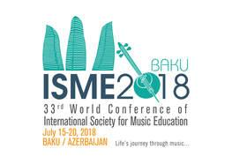

Life’s Journey Through Music

